Machrihanish Seabird Observatory
Founded September 1993 (26 Years)

October Report 2019
Compiled by: Eddie Maguire (warden)
Contact the Observatory...
Mobile - 07895 952640
E-mail – msbowarden@gmail.com
Website – machrihanishbirdobservatory.org.uk

Photo of the Month....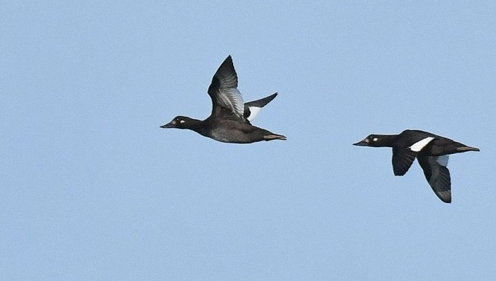
Velvet Scoters – fem/imms >S 11th October
A scarce passage visitor at MSBO

October Report 2019...
MSBO Northern Gannet overland Project....
Seasonal surveillance of adult Gannets embarking on the 8km / 9 minute one-way overland flight to the west from Campbeltown Harbour to Machrihanish Bay was finally concluded on 18th October (only 3 birds crossed during this period). Throughout the breeding season a total of 2,061 adults, presumably from the Ailsa Craig colony (Firth of Clyde), made the crossing this year – a record number; the previous high total was 1,461 crossing during March to October 2017.
A breakdown of this unique MSBO Project was published monthly during the 3 year period 2017 - 2019; see Tables 1 and 2.

List of Selected Species...

Whooper Swan
The Laggan; 8 (inc. 2 1cy) at West Parkfergus floods on 6th - 7th then 200+ arrived / present 10th – 12th (warden / Rob Turner).
Campbeltown; 9 >E on 25th and 12 >E on 31st (Martin Coffield pers comm.).

Greylag Goose
The Laggan; 280 at West Parkfergus floods on 6th.

Greenland White-fronted Goose
Arrival; 270 in-off-sea at MSBO on 21st.
The Laggan; one at Strath Farm floods on 25th and 143 there on 26th.

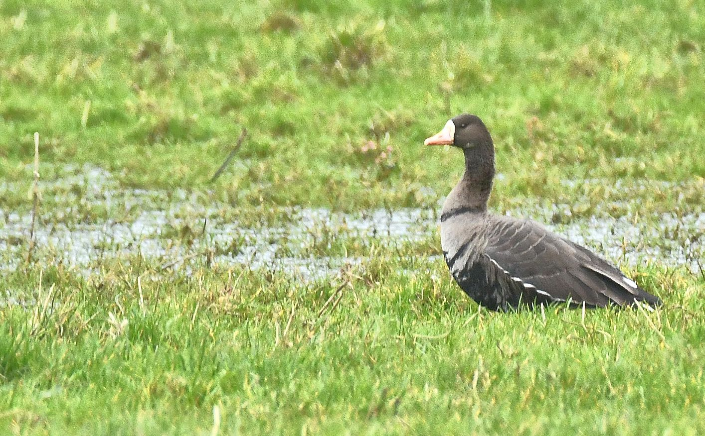
White-fronted Goose – at the Laggan floods 25th October

Pink-footed Goose
The Laggan; 7 at Strath Farm floods 2nd – 4th. A single bird there on 26th.

Common Shelduck
The Laggan; the first returning bird was at Strath Farm floods on 27th.
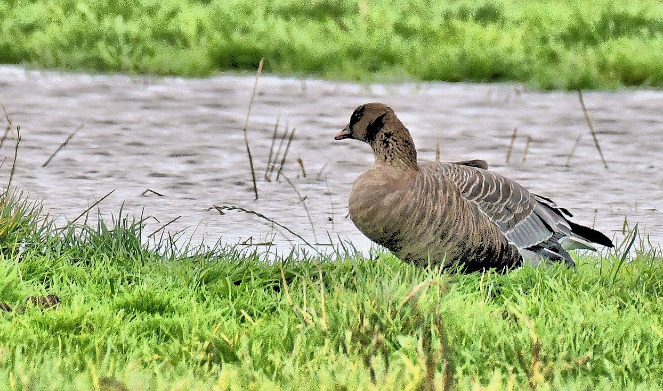
Pink-footed Goose – at The Laggan floods 4th October

Greater Canada Goose
The Laggan; 94 at West Parkfergus on 6th.

Eurasian Wigeon
Two by MSBO 1st – 2nd, 4 on 4th, flock 80 >S on 10th, one 14th – 22nd and 5 >S on 24th.
The Laggan; 30 at West Parkfergus on 6th.

Greater Scaup
A male >S on 3rd.

Common Scoter
A male >S on 5th and 6 >S on 14th.

Velvet Scoter
Two fem/imms >S on 11th.
At MSBO this species is a scarce passage visitor.

Long-tailed Duck
A fem/imm arrived after a heavy shower on 13th and was seen frequently to 18th.

Northern Gannet
1cy (juveniles) >S; one on 8th, 5 singles on 9th, one on 10th and 2 on 11th.
A total of 12 juveniles were logged >S at MSBO in recent months with one in August, 2 in September and 9 in October.
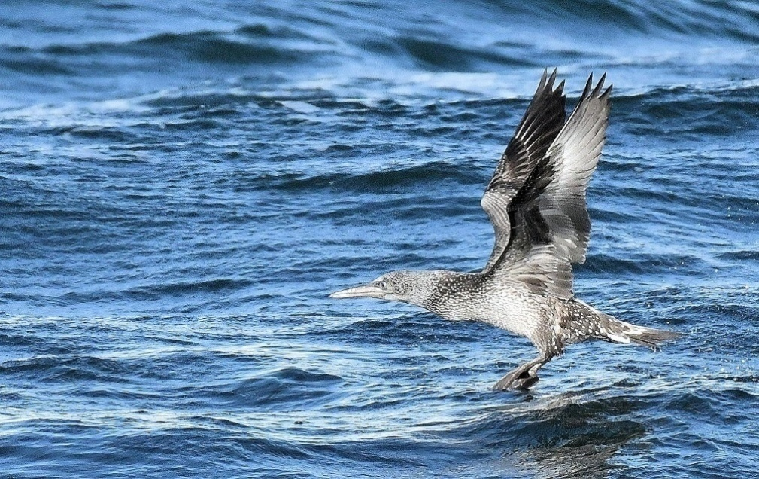
Same individual below

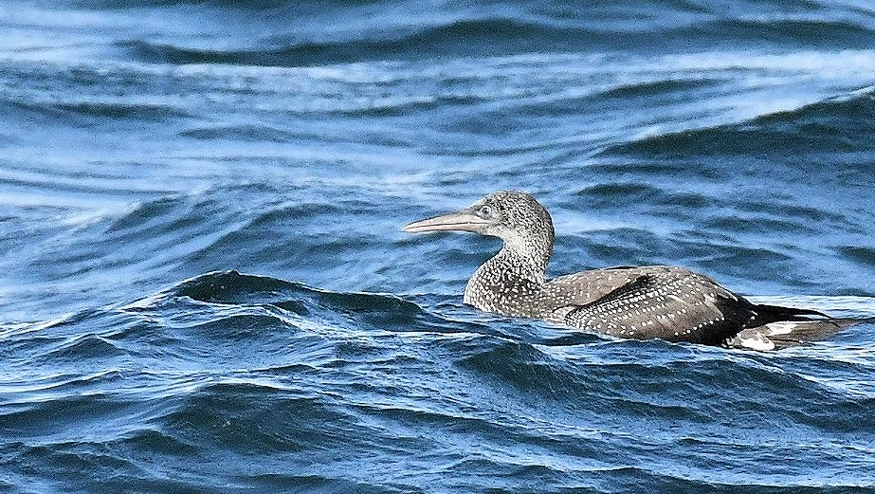
Northern Gannet – 1cy MSBO 12th October

MSBO Northern Gannet Overland Project / March to October 2019...
Table 1. Date / number of adult Gannets crossing 8km overland to the west from Clyde waters (Campbeltown harbour) to the Atlantic (Machrihanish Bay) during October 2019 along with wind direction / force and departure times of first / last bird.

Date  October  2019 | Number  Adults  crossing | Wind  Direction  & force | Campbeltown  Times of first / last bird flying W
3rd | 1 | E 5 | 15:44
4th | 1 | E 4 - 5 | 13:22
18th | 1 | NE 2 | 16:20
October Total | 3

Table 2. The numbers of adult Gannets that crossed west over Kintyre during March to October 2017 - 2019.
2017 | March | April | May | June | July | Aug | Sept | Oct
Monthly totals | 2 | 23 | 131 | 126 | 274 | 408 | 491 | 6
Cumulative totals | 2 | 25 | 156 | 282 | 556 | 964 | 1,455 | 1,461
No. days of  Observation | 27 | 29 | 22 | 24 | 31 | 24 | 30 | 20
2018 | March | April | May | June | July | Aug | Sept | Oct
Monthly totals | 6 | 45 | 78 | 336 | 121 | 247 | 372 | 16
Cumulative totals | 6 | 51 | 129 | 465 | 586 | 833 | 1,205 | 1,221
No. days of  Observation | 31 | 30 | 31 | 30 | 31 | 31 | 30 | 25
2019 | March | April | May | June | July | Aug | Sept | Oct
Monthly totals  (Average per day) | - | 61  - | 214  (7) | 181  (6) | 323  (10) | 624  (20) | 655  (22) | 3  -
Cumulative totals | - | 61 | 275 | 456 | 779 | 1,403 | 2,058 | 2061
No. days of  Observation | 31 | 30 | 31 | 30 | 31 | 30 | 30 | 18

During April to October 2019 a record 2061 adults crossed west over Kintyre on 162/231 days of surveillance.
The average number crossing over on 162 dates was 12.

Manx Shearwater
One >S on 9th.

Red-throated Diver
Singles >S on 5th, 8th, 5 >S on 11th and singles >S on 12th and 24th.

Great Northern Diver
The first returning adult – still mainly in breeding plumage – was offshore on 14th.

Little Egret
One was photographed >S at MSBO on 5th (Warden / Dee Brodie).
The third MSBO record.
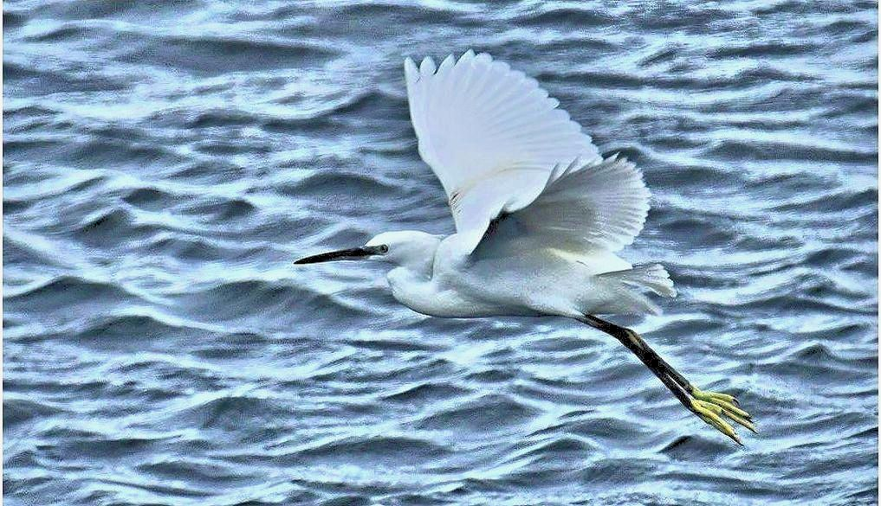
Little Egret - >S at MSBO 5th October

Hen Harrier
Southend; a male N. Carrine on 6th (Brian Morton pers. comm.).

Peregrine Falcon
A 1cy >N over the sea on 3rd and an adult was hunting around the point on 16th and 18th.
Carradale; one near Brackley on 5th (Brian Morton pers. comm.).
The Laggan; one West Parkfergus on 6th.

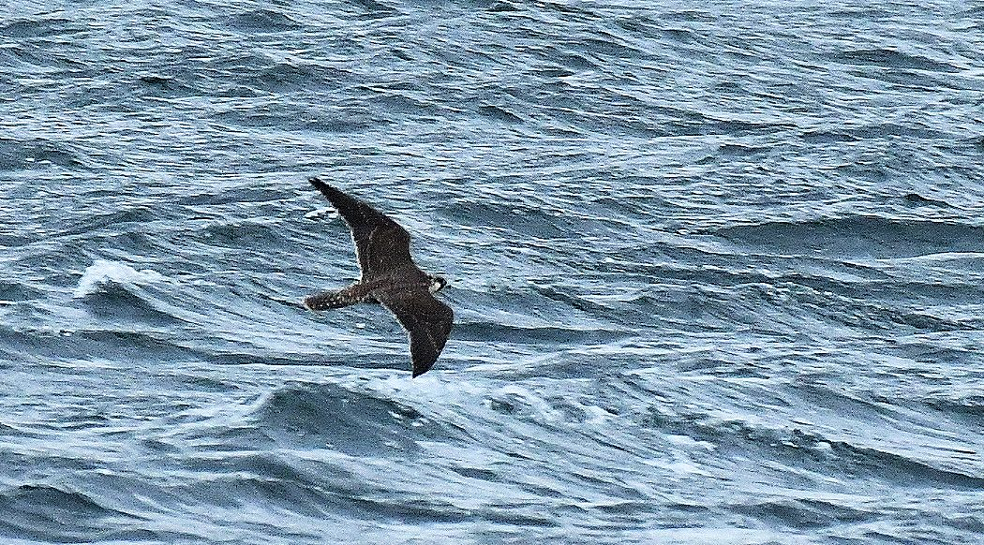
Peregrine Falcon – a 1cy off MSBO on 3rd October
Merlin
The Laggan; a male at West Parkfergus on 6th.
Loch Lussa; one at the north end on 6th (Dee Brodie pers. comm.).
One regular Machrihanish Airbase all month (David Millward pers. comm.).

Northern Lapwing
Westport; 390 on 20th (Dee Brodie pers. comm.).

European Golden Plover
Flock 370 by Clochkiel Farm on 2nd.
The Laggan; 53 at Strath floods on 18th.
Westport; 860 on 20th (Dee Brodie pers. comm.).

Common Ringed Plover
Two small flocks totalling 14 >S on 11th.

Dunlin
Three >S on 4th and 9 >S on 11th.

Purple Sandpiper
One appeared on 18th / flew around the point a couple of times then >S – a more typical passage date following a very early single bird that was seen briefly / photographed 51 days earlier (28th August). Later, 11 >S on 27th.

Sanderling
Two >S on 7th, 4 >S on 8th, 12 >S on 9th and 8 >S on 11th.
Red Knot
One >S on 1st.
A late fly-by after a superb autumn passage (see Table 3 below).
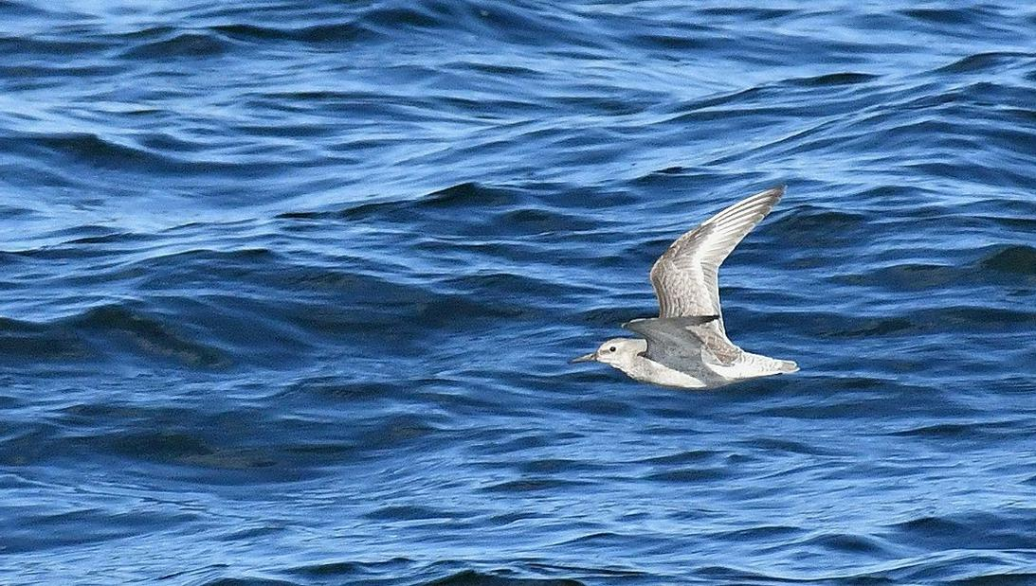
Red Knot - >S on 1st October

Eurasian Curlew
Tayinloan; 40 in field by Ferry Terminal on 25th (Dee Brodie / Jimmy McCallum pers. comm.).

Common Snipe
One in-off-sea then >S on 1st was first at MSBO this year.
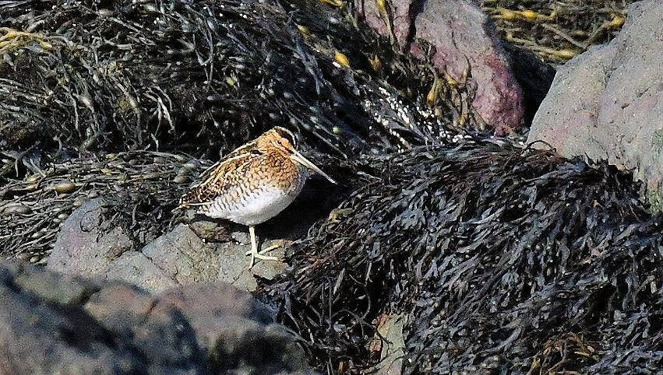
Common Snipe – MSBO 1st October
Visible migration of waders at MSBO autumn 2019...
From July to October a total of 6185 fly-by waders that included 17 species were logged >S at MSBO.

Table 3. Monthly totals of fly-by waders >S at MSBO during autumn 2019.

Species | July | Aug | Sept | Oct | Autumn  2019  Fly-by totals
Eurasian Oystercatcher | 628 | 1,007 | 76 |  | 1,711
Grey Plover | - | - | 3 |  | 3
Common Ringed Plover | 115 | 123 | 33 | 14 | 285
Whimbrel | - | 15 | 11 |  | 26
Bar-tailed Godwit | - | 3 | 6 |  | 9
Black-tailed Godwit | 10 | 16 | 105 |  | 131
Ruddy Turnstone | 28 | 176 | 74 |  | 278
Red Knot | 8 | 557 | 104 | 1 | 670
Ruff | - | 6 | 1 |  | 7
Sanderling | 496 | 504 | 118 | 26 | 1,144
Dunlin | 498 | 578 | 106 | 9 | 1,191
Common Sandpiper | 78 | 16 | 0 |  | 94
Purple Sandpiper | - | 1 | - | 12 | 13
Common Greenshank | - | 3 | 1 |  | 4
Common Redshank | 263 | 301 | 53 |  | 617
Grey Phalarope | - | - | 1 |  | 1
Common Snipe | - | - | - | 1 | 1
Monthly Totals | 2,124 | 3,306 | 692 | 63 | 6,185

Pomarine Skua
A 1cy >S at 11:10hrs on 24th (WNW f4-5 / squalls).
The first this autumn.

Black-legged Kittiwake
There was a light movement of 600+ >S / 5hrs on 9th.

Sandwich Tern
An adult and a 1cy >S on 7th.
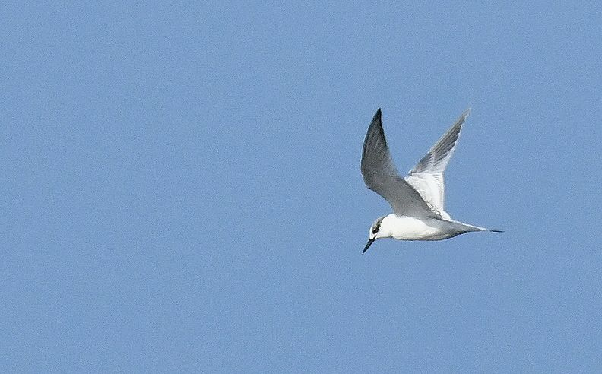
Sandwich Tern – a 1cy >S 7th October

Common Guillemot
Details of ringing recovery.
X49435; ringed as a chick on Glunimore (Sanda) 29th June 2019 (Rab Morton pers. comm.)
Found dead on ramp at Kennacraig Ferry Terminal / NW Kintyre on 11th October 2019 (Tommy Maguire pers. comm.).

White Wagtail
Passage birds >S were seen on 4 dates only with 10+ on 4th, 3 on 5th, 4 on 6th then last one on 8th.

Yellow-browed Warbler
Carradale; one in garden at Port Righ on 13th (Argyll Bird Club website).
The second one at this location this autumn following one there on 28th September (Jim Dickson / Argyll recorder pers. comm.).

Eurasian Jay
Carradale; 3 birds seen from the Brackley / Auchnabreck forest track on 20th (Dee Brodie pers. comm.).

Western Jackdaw
A most unusual sighting was a tight flock of ca. 40 >W 1 mile off MSBO on 27th.

Carrion Crow
In-off-sea from WNW; 2 >E on 16th, 3 >E on 18th and one >E on 21st.

Hybrid Crow
In-off-sea from WNW; one >E on 18th.

Hooded Crow
In-off-sea from WNW; 5 >E on 16th, 7 >E on 18th and 4 >E on 21st.
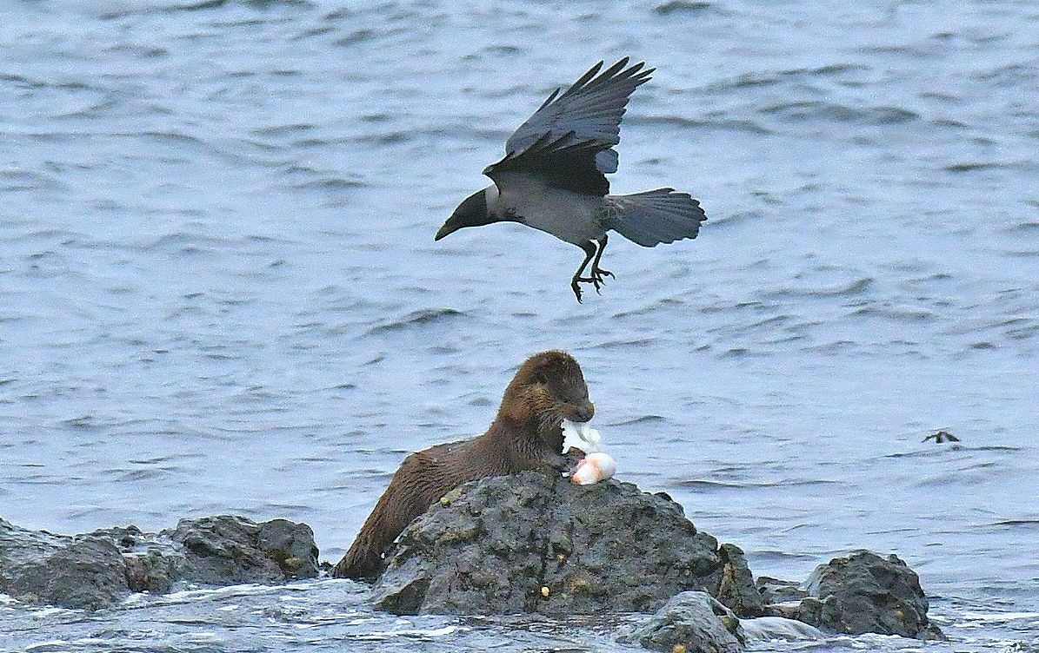
Hooded Crow / Otter – MSBO 21st October

Bohemian Waxwing
Campbeltown; 8 on a Rowan at Calton Avenue on 2nd (Alistair Anderson pers. comm.).

Common Starling
The Laggan; ca. 900 at West Parkfergus on 6th.
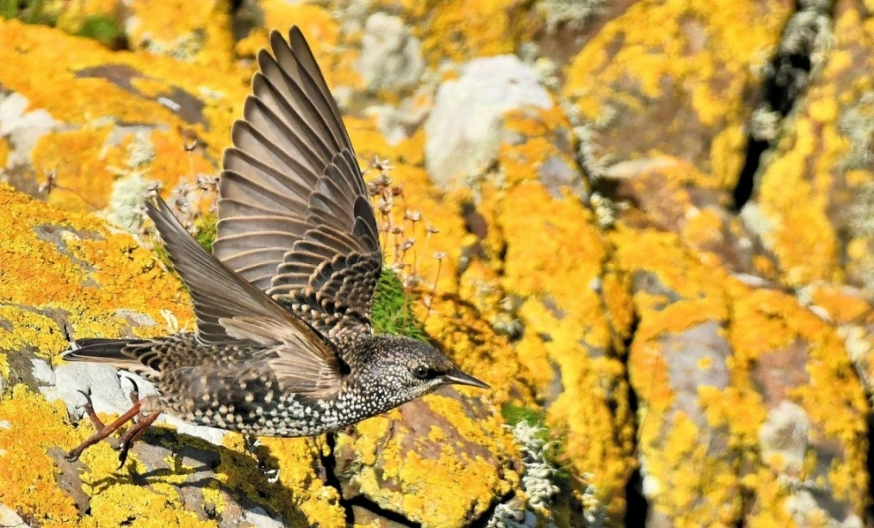
Common Starling – MSBO 1st October

Finally – a few more photos...

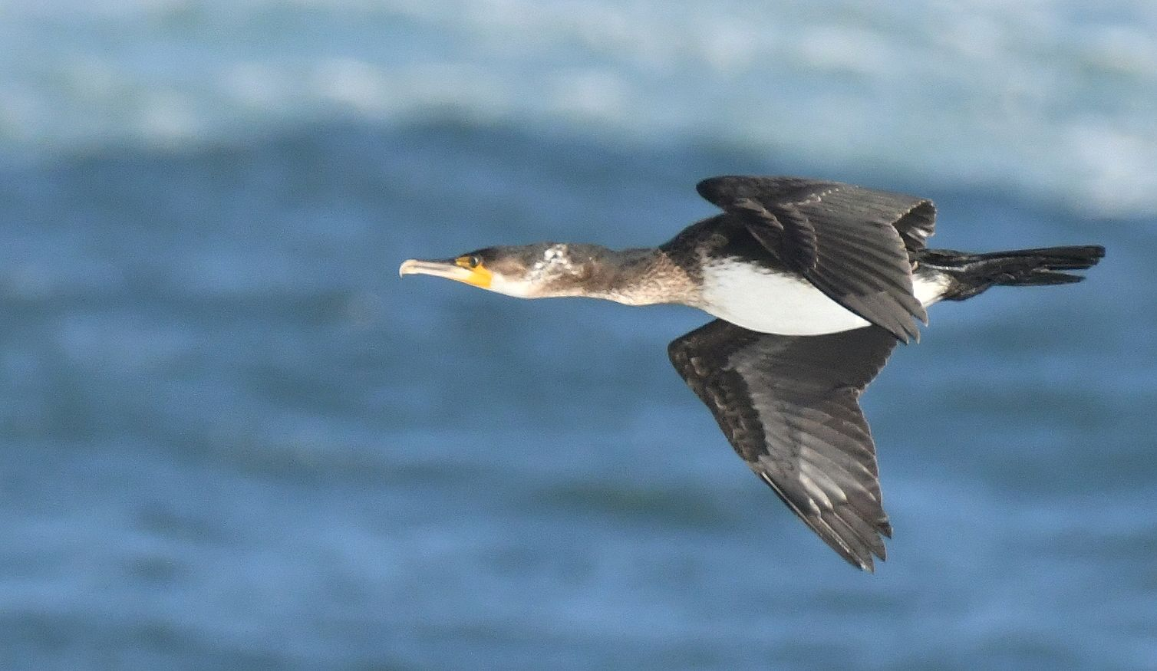
Great Cormorant – 1cy >S off MSBO 8th October

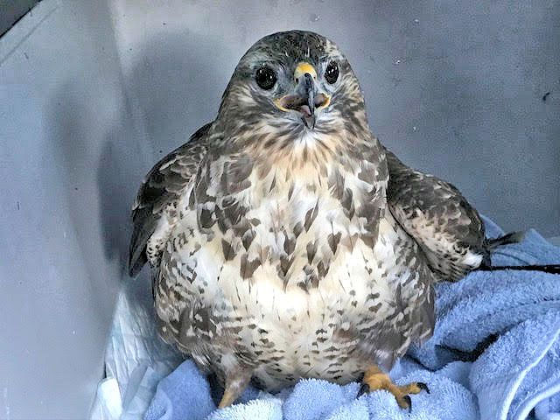
Common Buzzard – rescued 6th October / photo Ray Dobson
Found on track leading to Achnaglach off Southend Road

